Public Profile Report

Rozzi Fireworks

EJ Cervantes

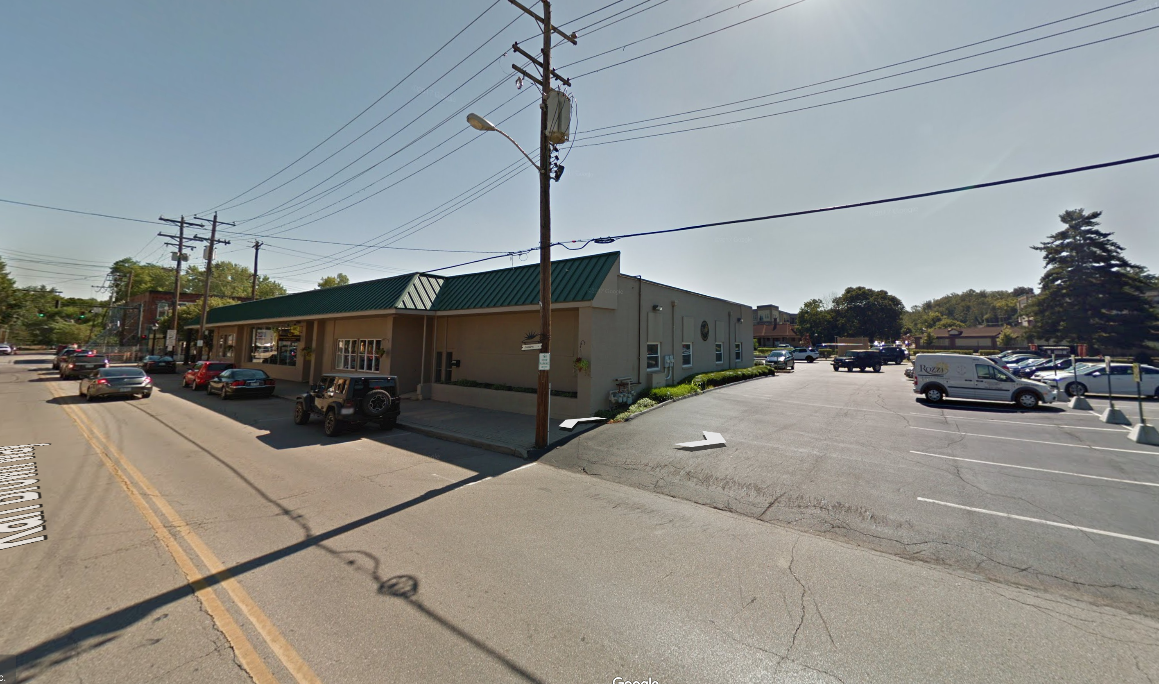
Figure 1: Street View of Rozzi Fireworks Main Offices

Company Background

Rozzi Fireworks is a Cincinnati based company that is a forerunner in the international fireworks industry. It was founded by Paolo Rozzi in Southern Italy 1895. They moved the company to Cincinnati in 1930 after the company underwent serious growth¹. It is a small company where the owners and VPs are members of the immediate Rozzi family. Rozzi Fireworks has less than 50 employees².

Company Background Analysis
At a quick look of the company it is obvious that they are a smaller family owned company. With this there comes a familiarity of workers and employees from the highest level all the way to the lower level store employee. Rossi is known for doing big firework shows and even participating in international competitions. The best point of entry off this limited information is to either pose and someone contracting their services, or as someone who is putting together a fireworks competition inviting them to participate.

Physical Location

Rozzi Fireworks main office is located³ at 118 Karl Brown Way, Loveland OH 45140 US. The office phone number is (513) 683-0620. A Google Search led to me discovering that this address actually is under the company name “Hewco Products Inc”. Using Google Maps most recent street view (Figure 1) it shows the store front belonging to Rozzi Fireworks. I was even able to see a company van parked next to the building (Figure 2)
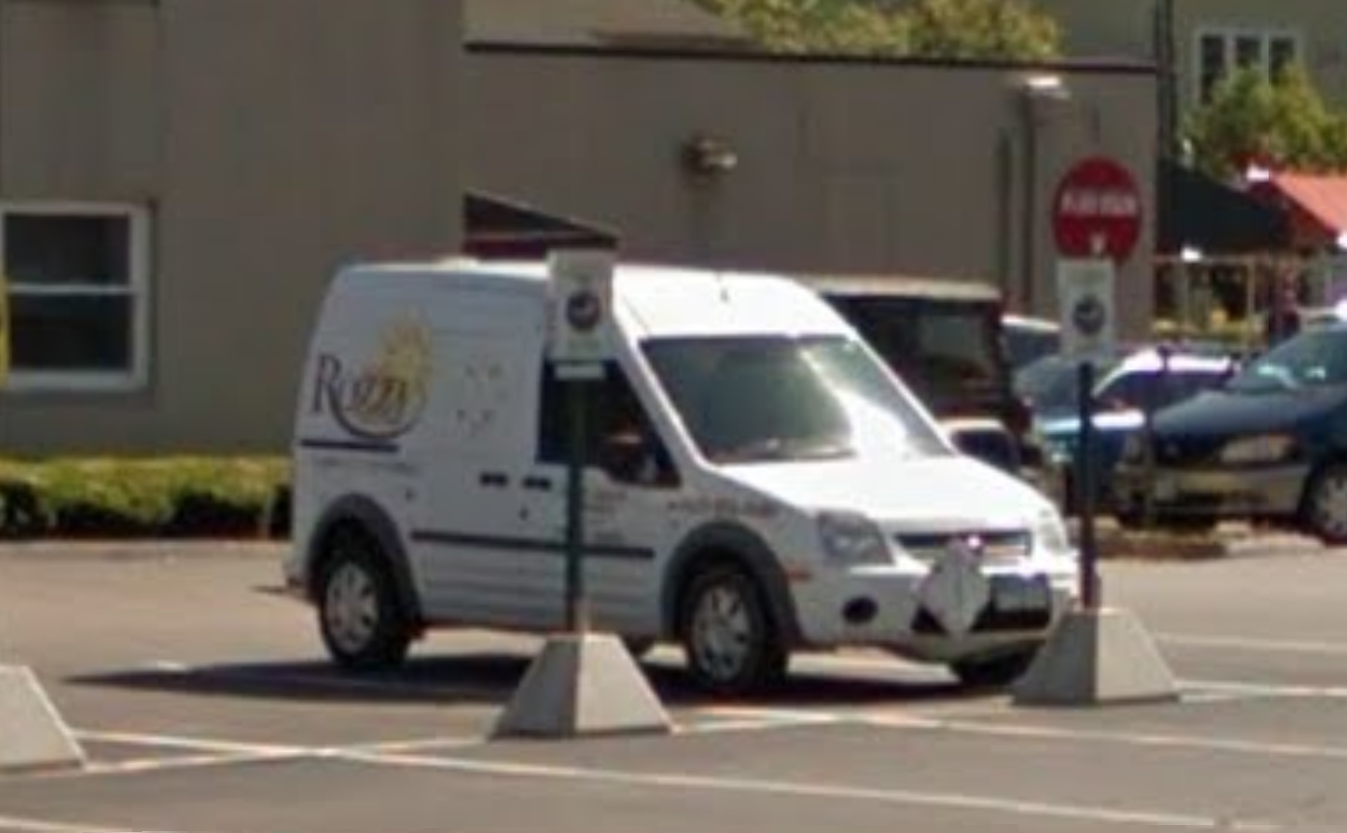

Figure 2: Rozzi Fireworks company van

It is safe to assume that this is the correct address for the main offices. Another interesting note is that Rozzi Fireworks has a local fireworks store located at 10059 Loveland Madeira Rd Loveland, Oh 45140(Figure 3)
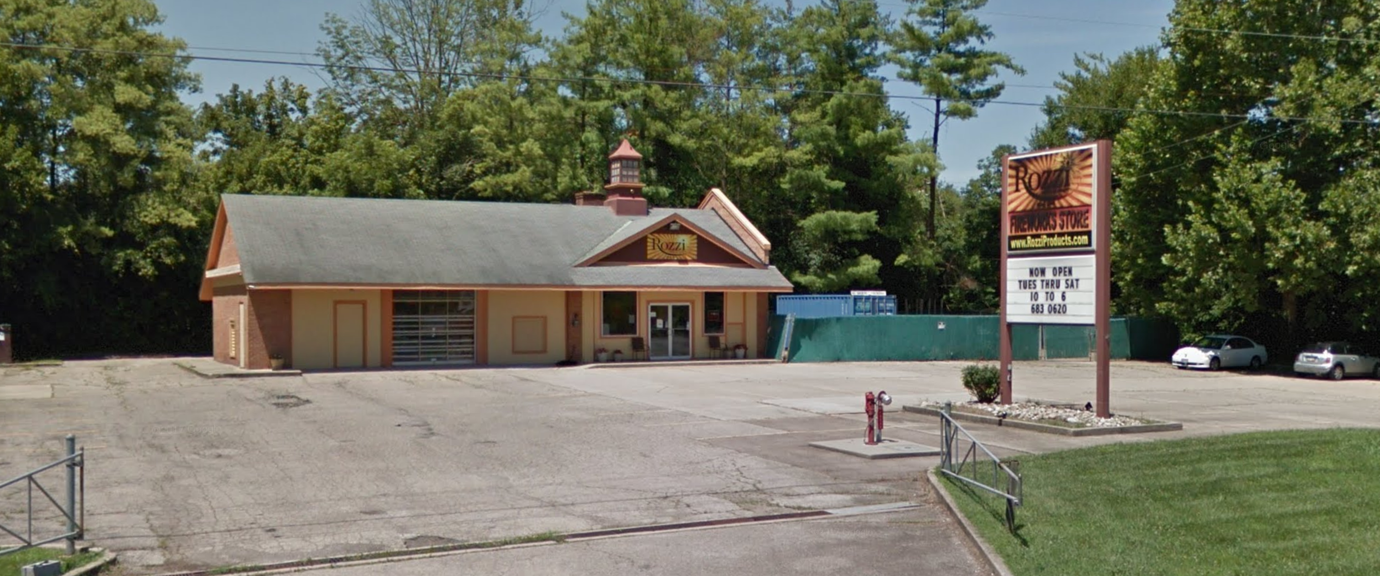
Figure 3: Rozzi Fireworks store

Physical Location Analysis

Having two different locations in the Cincinnati area helps provide multiple points of entries. One could either pose as an in person customer at the store front and try to do some more private social engineering for more information to have a better chance of going through the main offices

Information Technology

Information Technology Analysis

¹ Rozzi Fireworks About http://www.rozzifireworks.com/about-us/
² Glassdoor company information https://www.glassdoor.com/Overview/Working-at-Rozzi-Fireworks-EI_IE2184067.11,26.htm
³Contact Rozzi http://www.rozzifireworks.com/contact/

